

# Guide to Forking repos for instructors

**1.** Have your students sign up for [GitHub](https://github.com/) and download the [GitHub desktop client](https://desktop.github.com/).

**2.** Share the link to the primary repo you created with students (you can simply copy the browser link).

**3.** Have students create a Fork of your repo.

* With your students logged in to the cloud version of GitHub, select **Fork** in the upper right to create a Fork of the primary repo.

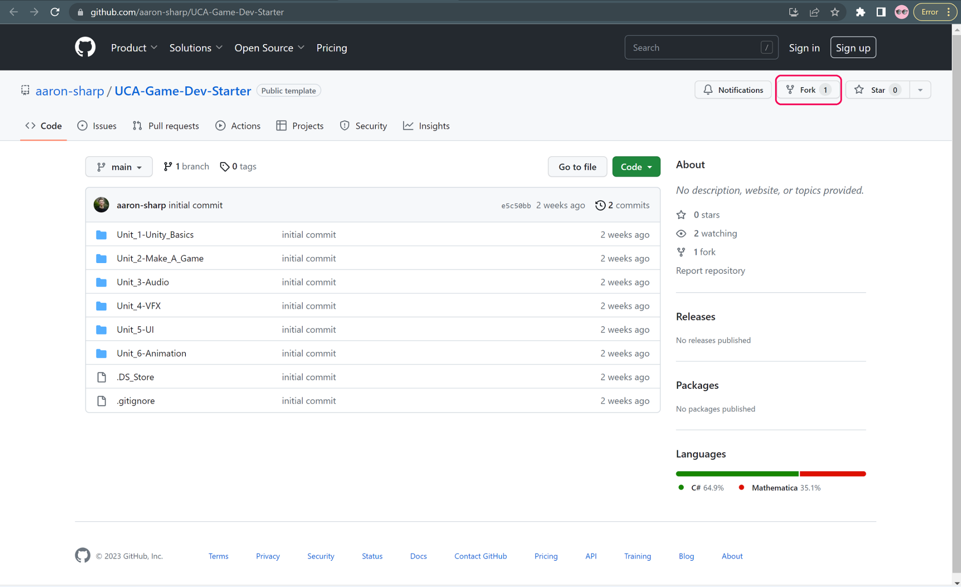

* Have students name the Fork such that you can identify it as theirs (use a common naming convention, e.g. FirstName_LastName_Game_Dev_101).
* Select **Create Fork**.

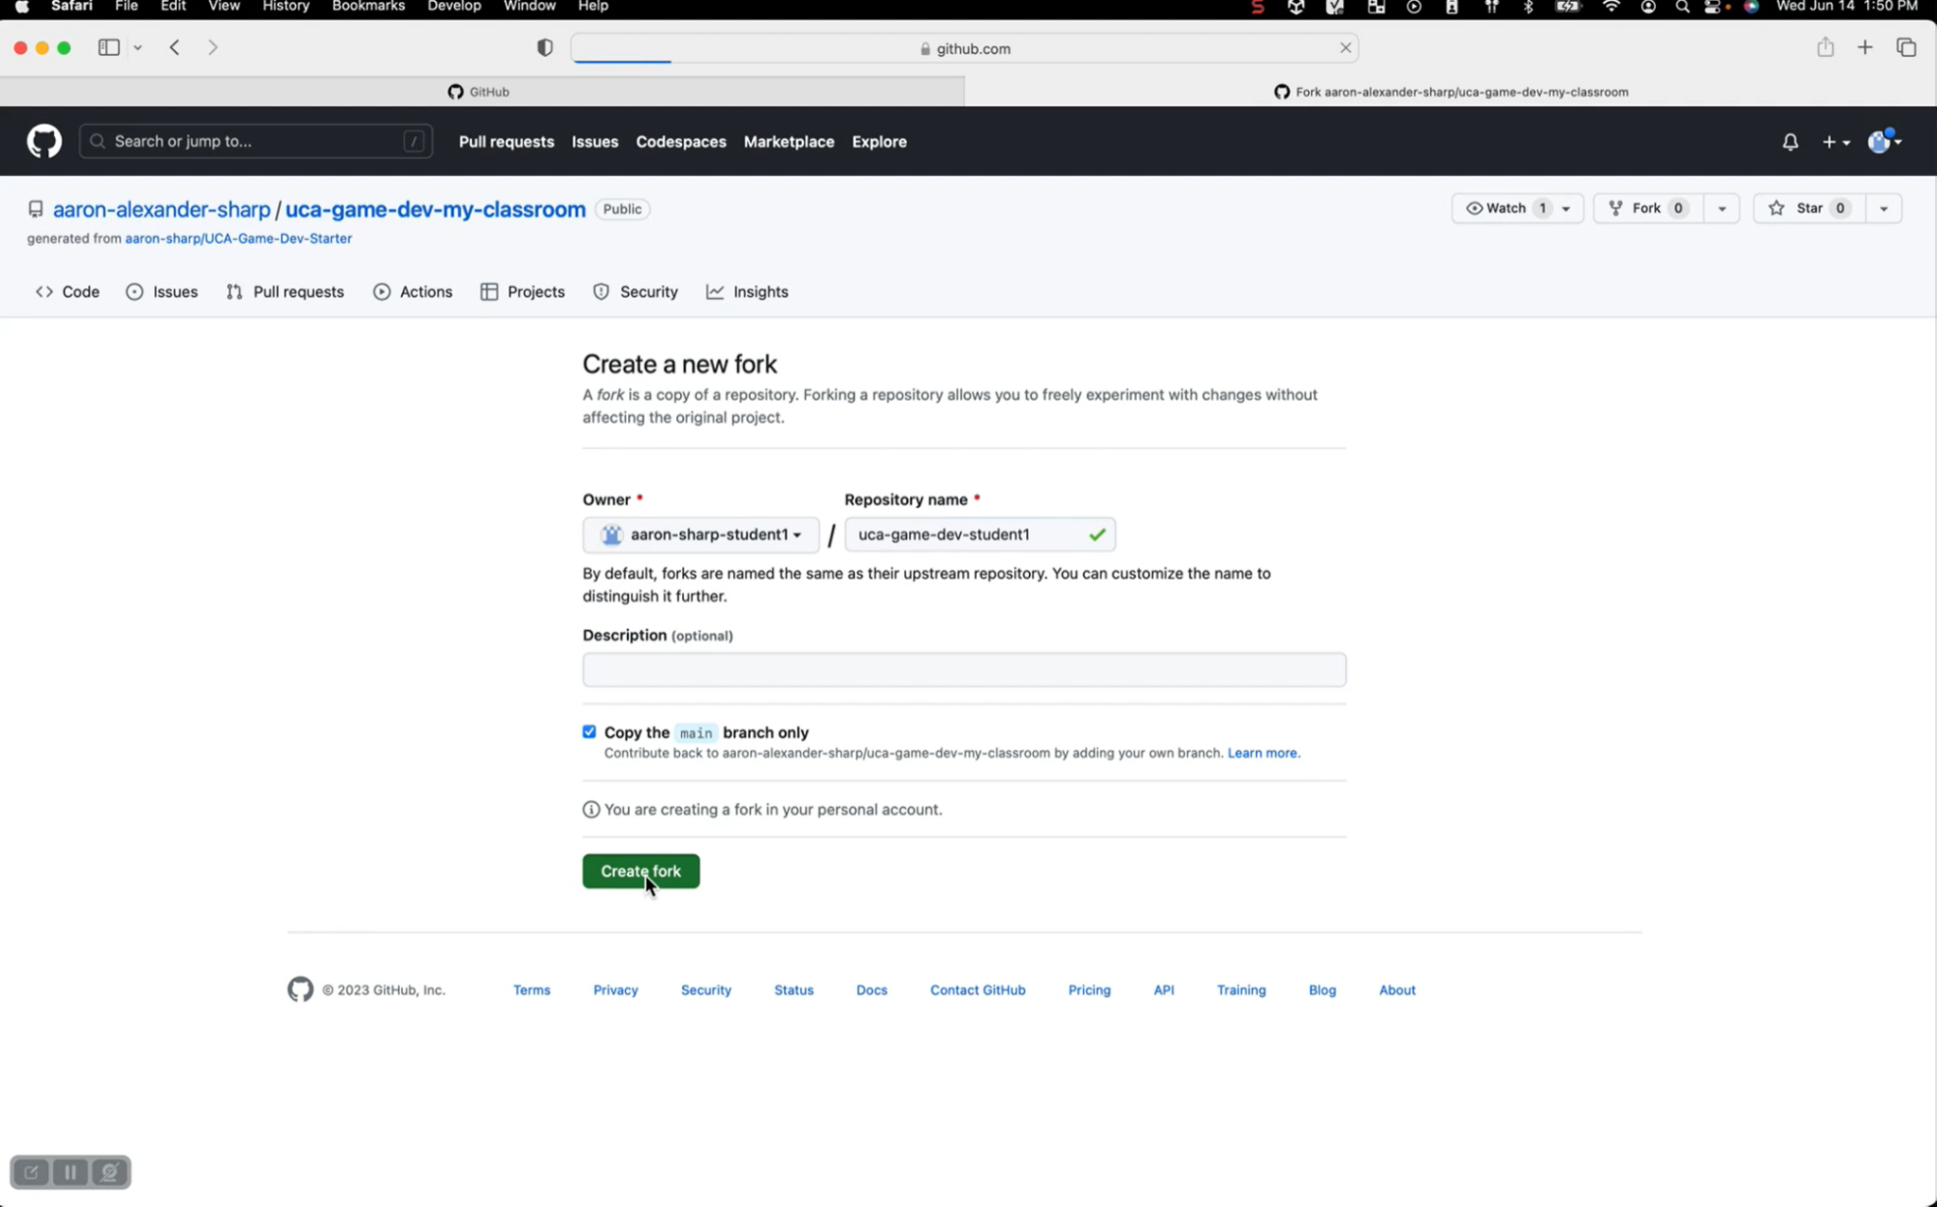

**4.** Have students open their Forked repo via the Desktop app.

* **Code** > **Open with GitHub Desktop**

Now your students can upload files to the appropriate project folder within their Forked repo, make changes to those files, commit, and push.